**Introduction**

**What are Azure Container Apps**

* Azure Container Apps is serverless platform that allows you to maintain less infrastructure and save cost while running containerized applications.
* With Container Apps, you enjoy the benefits of running containers while you leave behind the concerns of manually configuring cloud infrastructure and complex container orchestrators.
* Use the Azure CLI extension, Azure portal or Arm templates to your applications.
* Enable HTTPS or TCP ingress without having to manage other Azure infrastructure.
* Use specialized hardware for access to increased compute resources.
* Automatically scales based on demand.
* Supports reacting to events like HTTP request and queues.
* Ideal for building microservices architectures.
* Pay-as-you-go pricing for resource consumption.

**Architecture Diagram**

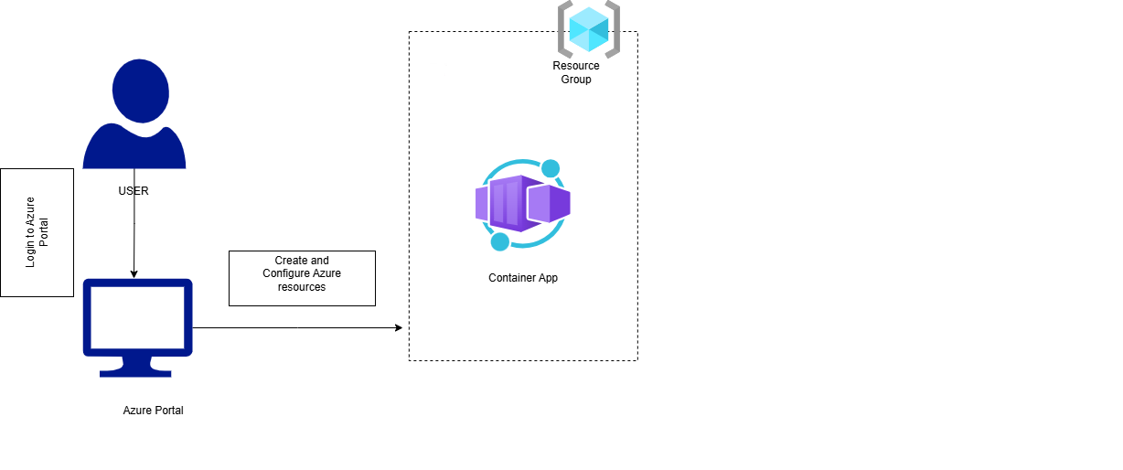

**Lab Steps**

**Task 1: Sign in to Azure Portal**

**Task 2: Create the Azure Container app**

1. From the All Services blade, search for **Container app** and select it.

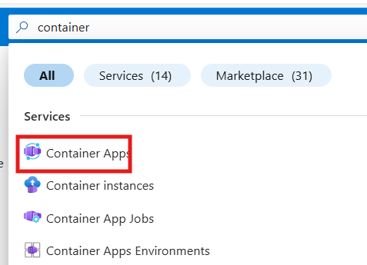

2. If it shows any error in the page, please wait 2 minutes and refresh the page. Backend resources will be created by that time. 

3. Click on **+ Create**.

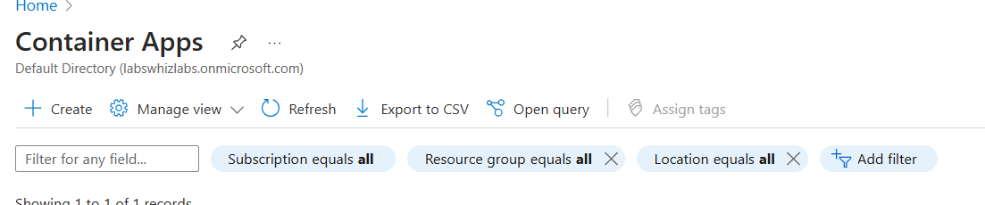

4. On the **Create Azure Container App** page, enter the following values in the **Basics** tab.

* Subscription: Leave it as default
* Resource group: Select **rg_centralus_XXXXX**
* Container app name: Enter a unique name
* Region: Select **Central US**
* Deployment Source: Select **Container images**
* Container App Environment: Select the existing one or Create new.
* Leave other options as default

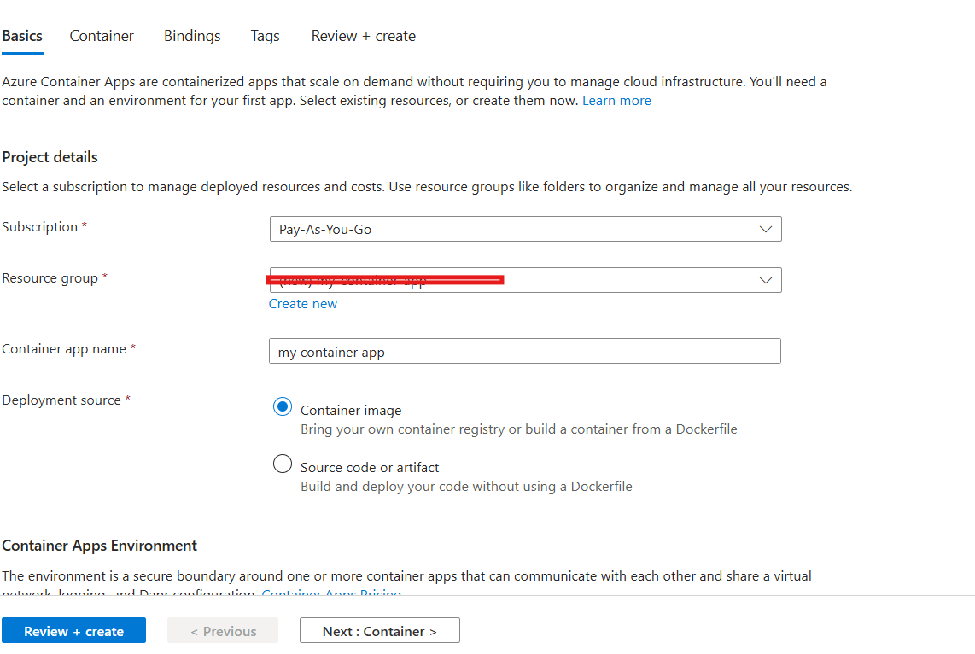

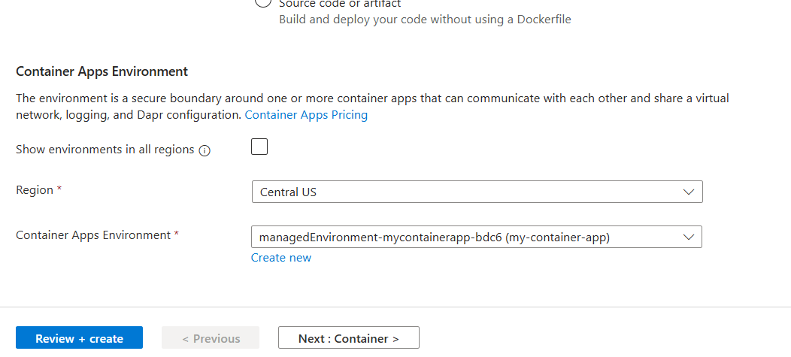

5. Click on the **Container** tab and enter the following values

* Use quick start image: Select the checkbox
* QuickStart image: Enter a globally unique name (Example: **Simple hello world container**)

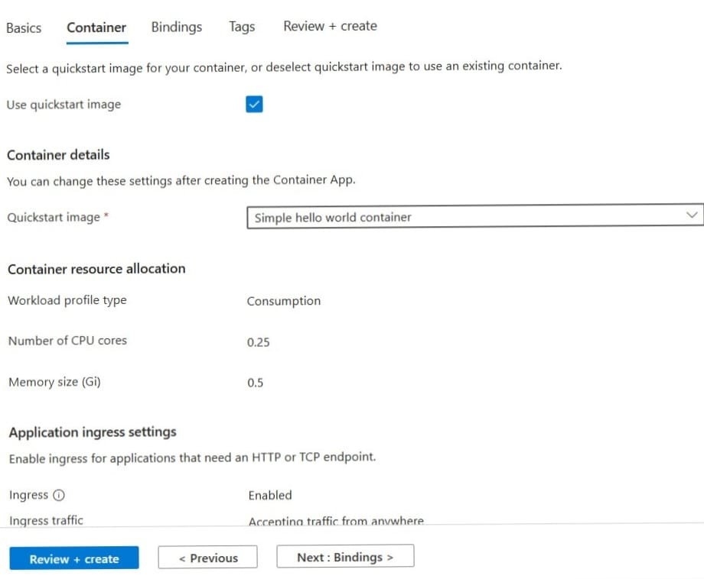

6. Click on **Review+ Create** and then select **Create**. Please wait for the deployment to complete.

**NOTE:** If deployment fails, it will be usually due to **DNS name label** to globally unique name in Step 5 and redeploy again. Usually it takes 2-5minutes for deployment to complete.

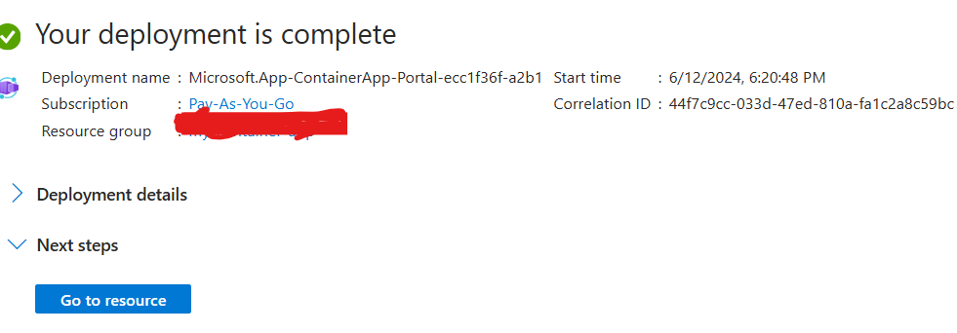

**Task 3: Test the Deployment** 

1. We will verify that the container app is running by ensuring that the welcome page displays.

2. Once the deployment is completed successfully, click on the **Go to resource** button on the deployment page.

3. On the **Overview** page of the container app, ensure your container Status is **Running**. Locate the Application URL and copy it.

* Example: [https://my-container-app.proudwater-d8f7fcc0.centralus.azurecontainerapps.io](https://my-container-app.proudwater-d8f7fcc0.centralus.azurecontainerapps.io/)

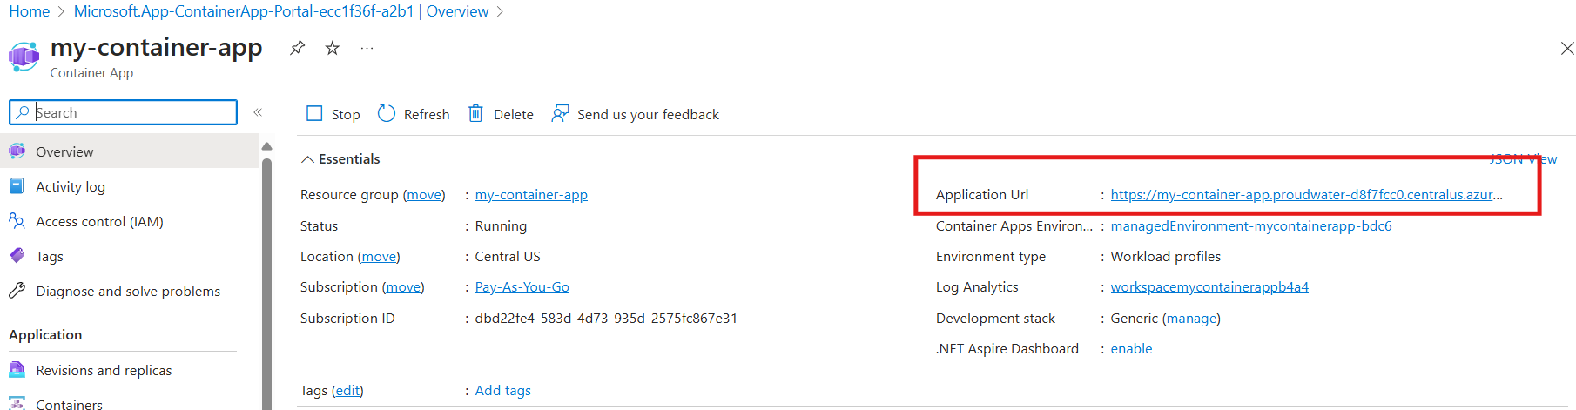

4. Open as new URL tab in web browser and press Enter. You will be able to see to welcome page as shown below

